**Major Assignment - 1**

**On**

**Python for Computer Science and Data Science 1 (CSE 3651)**

**Submitted by**

**Name : Dinanath Dash**

**Reg. No. : 2241004161**

**Semester : 5th**

**Branch : CSE**

**Section : 2241026**

**Session : 2024-2025**

**Admission Batch : 2022**



**DEPARTMENT OF COMPUTER SCIENCE & ENGINEERING**

**FACULTY OF ENGINEERING & TECHNOLOGY (ITER)**

**SIKSHA ‘O’ ANUSANDHAN DEEMED TO BE UNIVERSITY**

**BHUBANESWAR, ODISHA – 751030**

**MAJOR ASSIGNMENT-1: VARIABLES, OPERATORS, CONTROL STRUCTURES, AND FUNCTIONS.**

1. Write a Pythonfunctionbasic salarythataccepts twoparameters: hourly rateandhours worked per week. The function should calculate the basic salary per month (assuming a month has 4 weeks). If the hours worked per week exceed 40, create another function overtime salary, where every extra hour worked is paid at 1.5 times the normal hourly rate. Finally, create another function total salary that returns the sum of the basic salary and overtimeruntime. 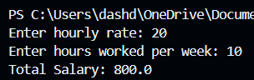
2. Create a function tax amount that shows how much taxes are deducted from the basic salary. Taxes are applied as follows: • If the salary is less than Rs. 60,000/-, deduct 10% as tax. • If the salary is between Rs. 60,000/- and Rs. 85,000/-, deduct 15% as tax. • If the salary is more than Rs. 85,000/-, deduct 20% as tax. 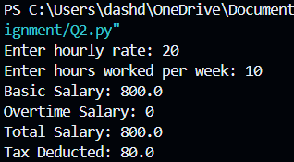
3. Using the function basic salary from Question 1, write another function gross salary that calculates the gross salary of an employee. This function should accept basic salary as input (output from Question 1), consider a fixed value of allowances (e.g., 20% of basic salary), and return the gross salary (basic salary + allowances- tax). 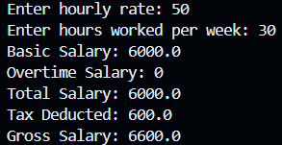
4. Using the gross salary function from Question 3, write a function salary bracket that categorizes the employee’s gross salary into one of the following brackets: • “Low income” if gross salary is below Rs. 50,000/-. • “Middle income” if gross salary is between Rs. 50,000/- and Rs. 80,000/-. • “High income” if gross salary is more than Rs. 80,000/-.

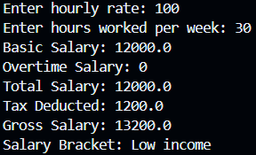

1. Take three different sets of employee names, hourly rates and hours worked per week as user input. Write a Python function employee report that generates a formatted report of all employees’ salary details. This function should print the employee names, basic salaries, gross salaries, tax amounts, and salary brackets in a readable format. 